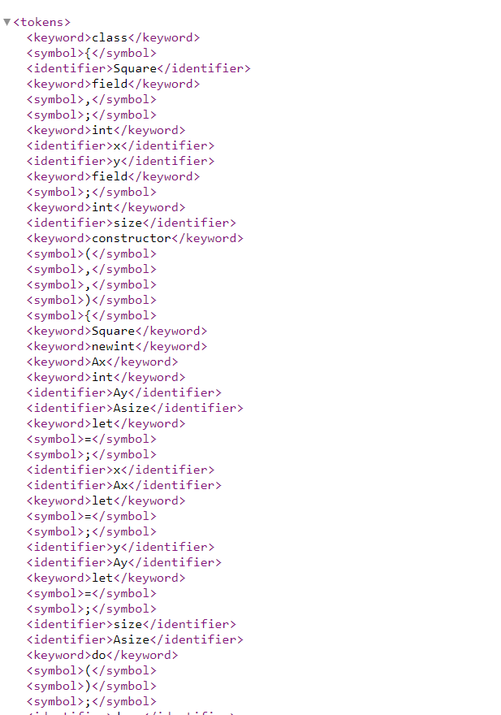

\*”Main.jack” xml screenshot

For this project, I wanted to write the program with Python as I am still a beginner to the language and wanted more practice with it. I knew that I would have to read the .jack files and, line by line, parse each word/character into their appropriate categories. I had never written xml files before, but thankfully after looking up some online examples it wasn’t difficult. The hardest challenge I had was actually the tokenizing part, namely separating symbols from identifiers and making sure I didn’t have any repeating tokens, which I did have for a while. Also, since I have limited Python knowledge, I had some learning curves there with some Python syntax, but thankfully it was easy enough to pick up on. The biggest takeaway from this project is that I am a bit better at Python now, and I have experience in parsing text files.